Group 2’s Meeting Journal:

Group Members: Michael Adams, Carlos Ibanez, Jose Amiot

Project Name: Panther

Outline: All members will meet on Each Thursday at 17:00. Members who do not attend the meeting must report the reason to the group. If a meeting does not occur it will be written in the project notes.

* Meeting 1: Today is 2023/06/08, the time is 17:30.
* Who Attended: Carlos C, Michael A. Jose could not make it due to in climate weather.
  + Carlos and Michael are going over the team project requirements.
  + We are figuring out how to fill-out the Gannt chart.
  + Carlos has recommended we take photos each week to confirm attendance.
  + Michael is working on filling out the Gannt chart and Carlos is reviewing what are the next steps for the next meeting.
  + Carlos proposed we work on the Gannt chart sing Microsoft teams, so the both of us can edit the same file.
  + We had trouble linking the chart to an online source, but we were able to complete half of the chart.
  + Meeting concluded at 18:20.
  + 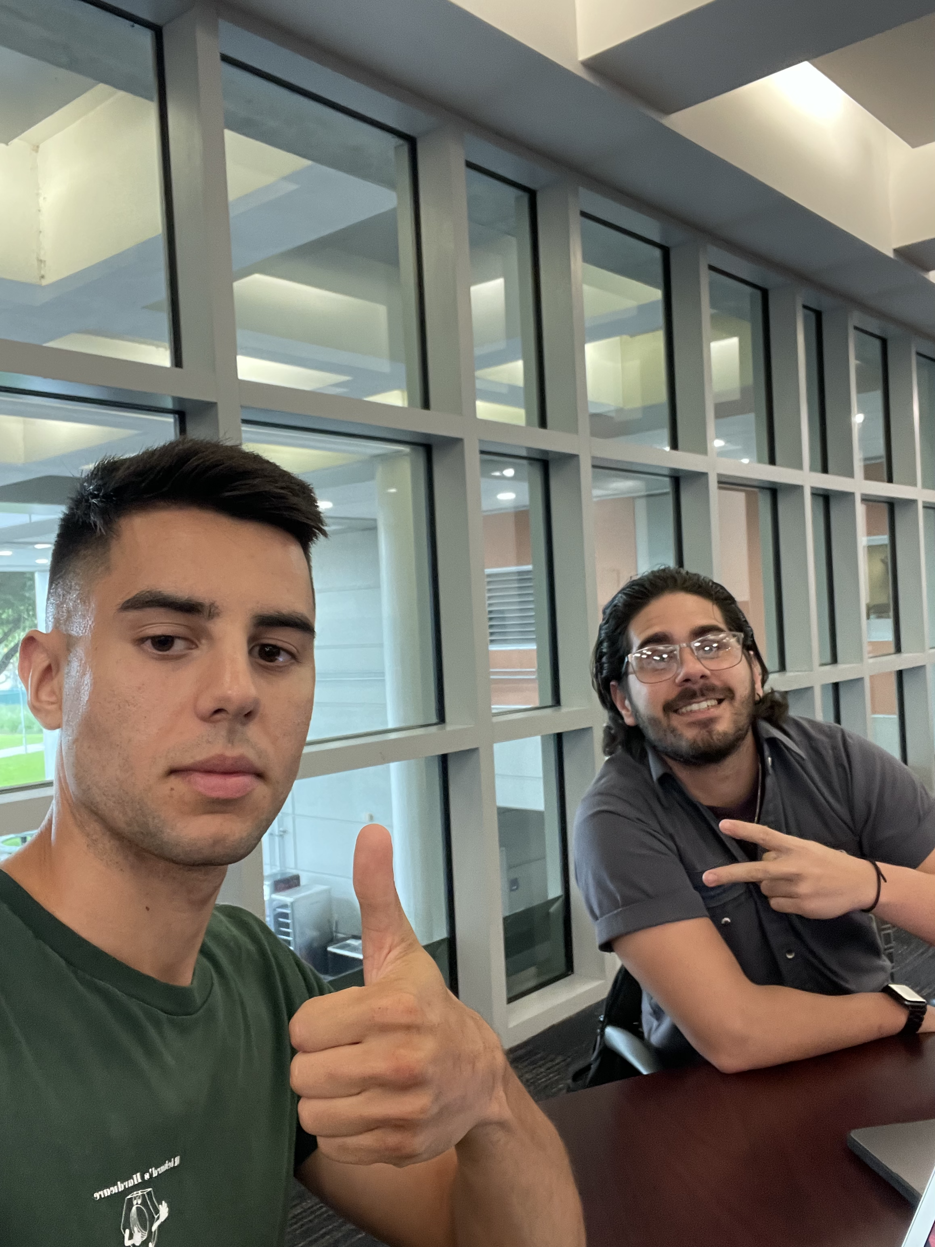

Meeting 2: Today’s date is 2023/06/12.

Today is Monday, the time is 16:30. All group members attended this meeting. The group went the Gantt chart and all members approved this week’s assignment. Each member is to produce a use-case diagram for our application. Here is the use-case of each member:

* Michael Adams- “User wants to submit attendance”.
* Carlos Ibanez – “Validate localization”
* Jose Amiot – “Calculate attendance for student.”

While discussing the use-case diagram, the group approved the following concept:

When the user logins to the app, they are directed to MyFIU. After they loggin, the link will take the information from MyFIU to determine if the user is a professor or a student. The interface will be different between professor and student. The application will also import the user’s class schedule and information.

The meeting has concluded, the time is 16:48.

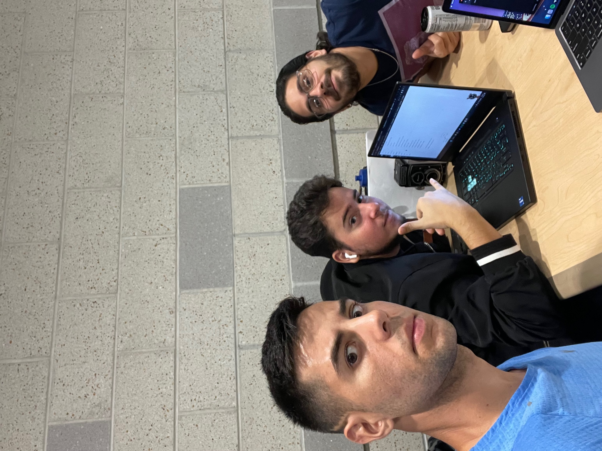

Meeting 3: Today’s date is 2023/06/22.

Today is Friday and the time is 13:20. All members are present, and the meeting is in-progress. Jose has let the team know that he is still in the process of completing his use-case chart which will be completed by next class. Jose is almost complete with his 1.5 of chapter 1. Michael has appended his use-case diagram to rename it “getAttendance”. This defines the process of theuse-case and will be a standalone method for a uml Carlos said he is pretty good. He has been working very hard on the project.

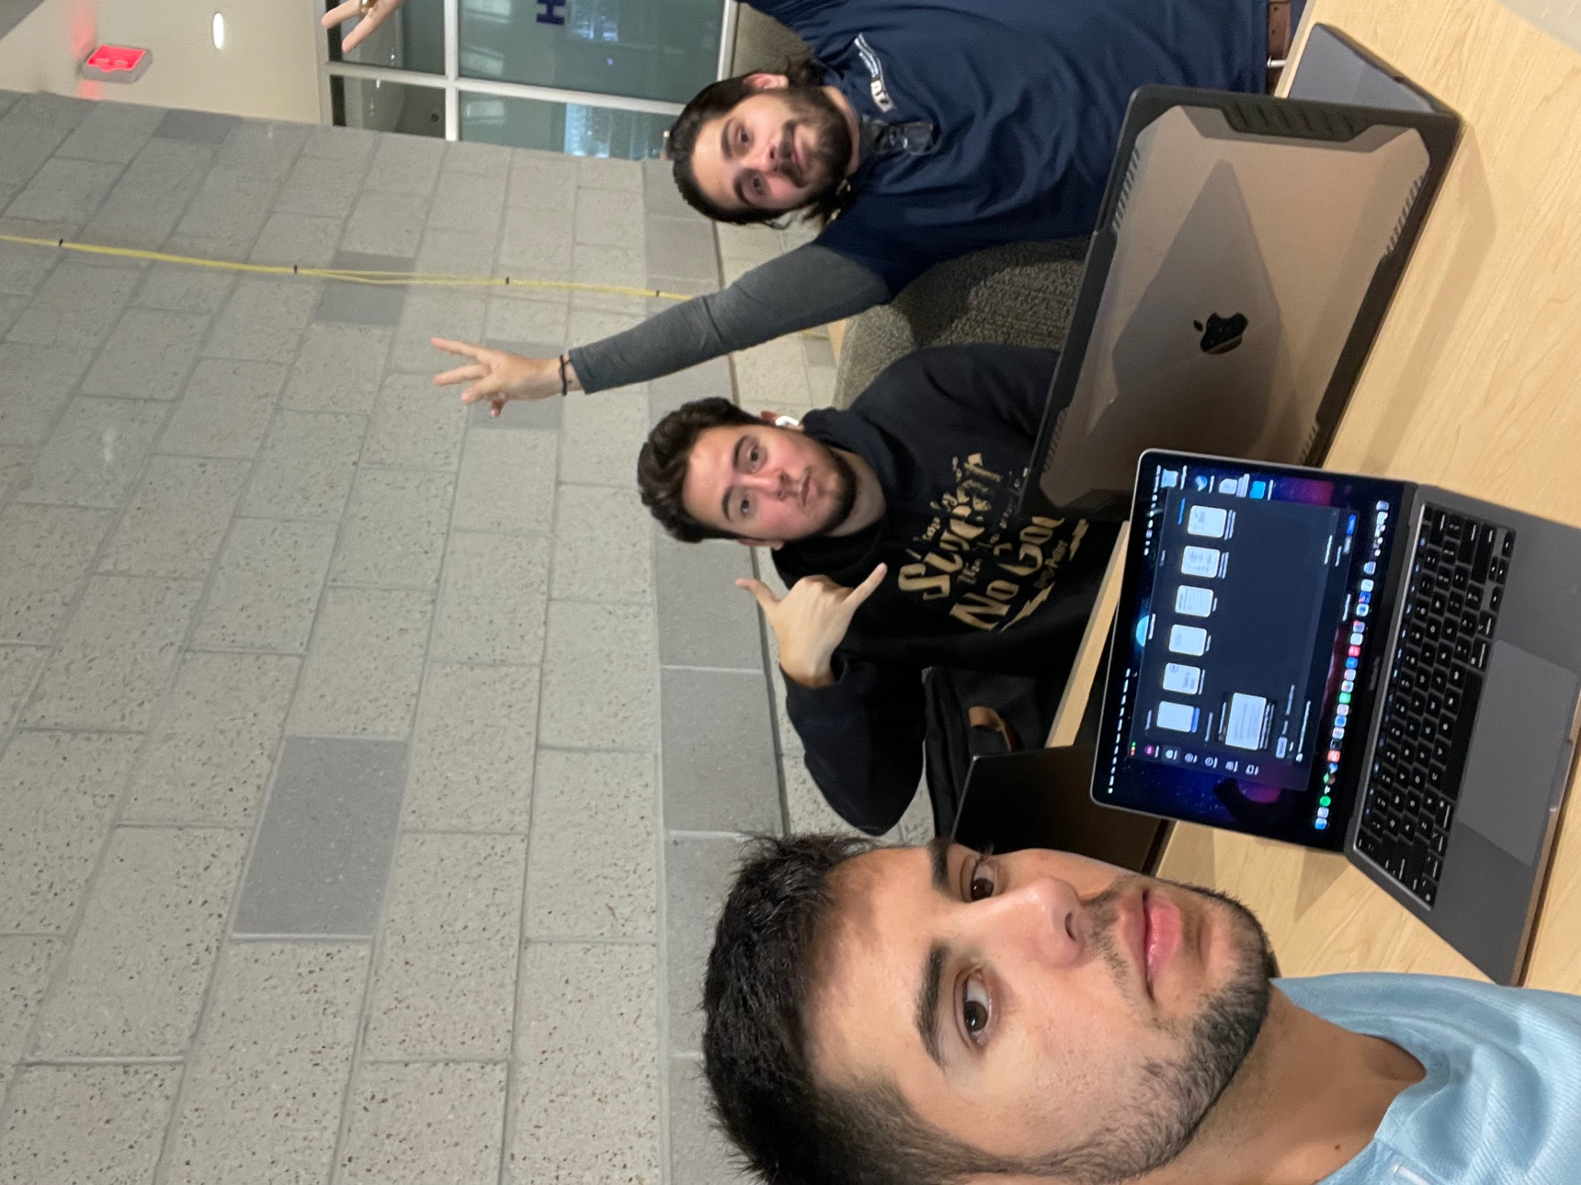

Meeting 4:

Today is Monday, the time is 19:00. All members are present for this meeting.

All members are working on the second deliverable for the group project. All members will agree on the following:

* Michael: 1 object, 1 sequence diagram.
  + Object (decomposed uml without methods): Login procedure
  + Sequence (the stick figure): attendance
  + Security Use-Case: logout
* Jose: 1 object, 2 sequence.
  + Object: ~edit attendance.
  + Sequence: send notifications, calculate attendance.
  + Security Use case: Login, validate.
* Carlos: 2 objects, 1 sequence
  + Object: Login, logout.
  + Sequence: validate.

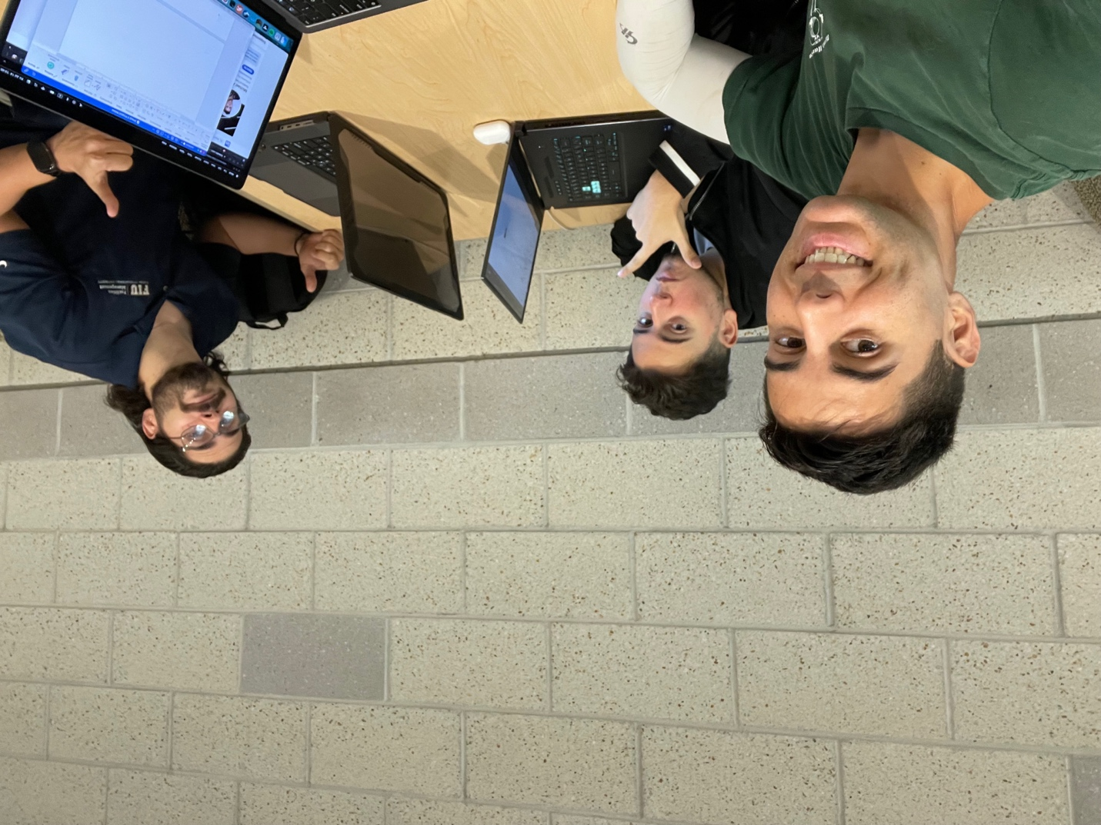

Meeting 5:

* Michael: 1 object, 1 sequence diagram.
  + Sequence (the stick figure): attendance
  + Use-Case: logout, read schedule: Complete
  + Use-Case Scenario: read schedule, Logout
  + Use case diagram: read schedule.
  + 1 Static model (3D square): Entire Project
* Jose: 1 object, 2 sequence.
  + Object: ~edit attendance.
  + 2 Sequence: send notifications, calculate attendance.
  + 1 Update Class model
  + Use-Case: Editing Attendance, Send Email Notification
  + Use-Case Diagram: Editing Attendance, Send Email Notification
  + Use Case Scenario: Edit Attendance, send email Notification
* Carlos: 2 objects, 1 sequence
  + Object: logout, contact professor.
  + Use-Cases: login, chat with professor
  + Use-Case Diagram: logout, contact professor, log-in
  + Use-Case Scenario: Logout, Chat
  + Sequence: Logout:
  + Security Use case: Login, message Professor.
* 6 use cases :5/6 , Carlos missing one
* 6 use case diagrams(oval with people): 2/6
* 6 use case scenarios: <= 1 paragraph : 0/6
* 1 static model : Michael
* 1 class diagram Update Jose
* 4 sequence diagram : Missing Jose. 2/4
* 4 object diagram: Missing One Carlos 3/4